Change of Circumstance Form
This form is for Training Providers to notify the RACP of a change of circumstance and the impact of the changes.

Change of Circumstances Overview
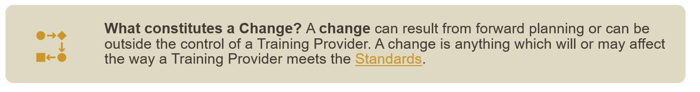
Training Providers are required to document and notify the RACP of any changes to their Training Program, Setting, and Training Network which may affect training and/or their accreditation status. The Training Provider submits the change to the RACP through a Change of Circumstance form.
Where changes are planned, and it is foreseeable that training will be impacted as a result, the Training Provider has the responsibility to notify the RACP to endorse impact mitigations for these changes prior to implementing the modification ( refer to Appendix 1 for the details on the consequence). Where changes are necessary because of external, unplanned influences, the Training Provider should notify the RACP in a timely manner so that any potential impact and/or consequences for ongoing accreditation can be assessed appropriately by an accreditation committee.

How to complete this form

To complete this form:
- Read the Managing a Change of Circumstance process
- Complete the Managing a Change of Circumstances form (this document)
- Submit this form to the Training Accreditation Services at the email address below.

Aotearoa New Zealand | Australia
Email:  Training Accreditation Services AoNZ  Call:  0508 697 227 (+64 4 472 6713)  9am to 5pm, Monday to Friday | Email:  Training Accreditation Services AU:  Call:  1300 697 227 (+61 2 9256 5444)  8:30am to 5:30pm, Monday to Friday
If you need assistance completing the form, please contact the Training Accreditation Services via the details above.

TRAINING PROVIDER DETAILS

Setting name
Address
Training Network name
(If applicable)

Training Program | (Please select one.)
Is this a multi-campus Setting? | Yes | No
(If you have selected yes, please provide details below)
Campus name(s)
(If applicable)

KEY TRAINING PROVIDER CONTACT DETAILS
This could be the Executive Director, General Manager, Director of Medical Services, Clinical Director, Chief Medical Officer, Director of Physician/Paediatrics Education.

Name
Position title
Email
Phone

SCOPE OF CHANGE
Please indicate what elements of training will or have been impacted. You may need to select more than one checkbox.

Training Network
Setting
Training Program |  | Adult Internal Medicine | Paediatrics & Child Health

If this is a multi-campus Setting, is the scope of change applicable to other campus(es)? |  | Yes | No

DETAILS OF CHANGE

DESCRIPTION OF CHANGE
Please describe the planned change or change which has occurred because of an unplanned event. Please also add any supporting documentation if required.

DATE OF CHANGE
Please indicate the date that the change was implemented, and the date that trainees and educators were notified. This can also be the date when you expect the change to be implemented and the date when you expect to notify trainees and educators.
Date change implemented | (Please select date.)
Date educators were notified | (Please select date.)
Date trainees were notified | (Please select date.)
If trainees and educators have not been notified, please provide reason why

IMPACT OF CHANGE (Optional)
What is the implication of this change? Describe both positive and negative foreseeable outcomes for trainees, educators, the training program, settings, and the integrity of the training experience. Please note: You only need to complete this section where there is an identified impact for the change. If there is no impact, please leave blank.
Outcomes | Positive | Negative
Training Program
Setting
Trainee
Educators

CHANGE MANAGEMENT (Optional)
Please describe the actions taken to mitigate the change.

TRAINING PROVIDER AUTHORISATION
Director of Physician/Paediatric Education |  |  | Setting Executive Name
Signature |  |  | Position title
Date |  |  | Signature
 |  |  | Date

To sign electronically, follow the instructions below:

1. Double click on the signature box.
2. You can choose to type, ink or select an image to use as your signature.
3. Click ‘Sign’.

Appendix 1 – Change and consequence

A change may include but is not limited to:
- changes to a Setting’s services, resources, and infrastructure
- changes of a Training Provider’s governance and management
- increases in trainee numbers and decreases in educator numbers
- reductions in training administrative support, infrastructure, resources, or opportunities
- revisions of a Training Program
- absence of senior staff with significant roles in physician training for an extended period without a replacement
- rostering changes which alter access to supervision and/or exposure to training opportunities
- any incident or circumstance which could impact the Training Provider’s integrity or capacity to deliver service and/or Training Programs.

Consequence

Conditions and recommendations are classified by the impact and consequence of the issue on the quality of training, patient safety and trainee and/or educator wellbeing. The RACP classifies issues as minor, moderate and major consequence. The action taken by the RACP is determined by these classifications.
Minor consequence
An issue identified which has low impact on the quality of training, Training Program, and training system in place at a Setting or Training Network.
Accreditors and the relevant committee will be notified of any issues of minor consequence at each committee meeting, and it may be considered at the time of the next accreditation review. The recommended review timeframe for a minor consequence is at the next comprehensive review (i.e., 4 years). It is typical for a recommendation to be a minor impact on training or safety.
Moderate consequence
An issue identified which has a substantial impact on the working conditions of trainees and/or educators and possibly on the training provided. This issue may impact patient safety and/or trainee and educator safety or wellbeing.
The issue can result in a condition or recommendation being placed on a Training Program, Setting, or Training Network. The recommended review timeframe for a moderate consequence is within 12 months.
Major consequence
An issue identified which has a serious impact on training, patient safety and/or trainee and educator safety or wellbeing. The issue can result in an immediate focus review or modification of a Training Program, Setting, and Training Network accreditation status.
The recommended review timeframe for a major consequence is within 3 months. 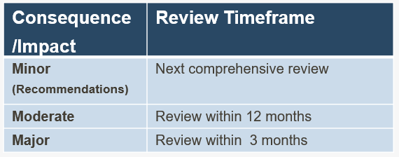

Appendix 2 provides examples of changes

Appendix 2 – Example of Changes

The table below provides examples of changes which may occur within training for which the RACP should be notified. This table is regularly updated and is available on the RACP website.

The list of changes is not exhaustive and will be built upon over time as further examples of change are experienced by Training Providers.

Examples of Change
Governance
Change to the Settings within a Training Network
Closure of a Setting
A Setting affiliating with a smaller Setting
A Setting or Training Network merging with one of more Settings or Training Networks
A Setting or Training Network splitting
Change to the services and level of care offered by a Setting
Training changes between Settings in a Training Network
Change to training governance and management in a Setting or Training Network
Abolition of medical education unit
Changes to structure of medical education unit
Reduction to physician authority, funding and support staff
Reduction of training facilities and resources
Rotation of a trainee to an accredited Setting or Training Network to which the Setting or Training Network has not previously rotated trainees
Rotation of a trainee to an accredited Setting or Training Network to which the Setting or Training Network has previously rotated trainees but not to the specific accredited Rotation
Absence of medical staff with significant roles in training with no replacement for more than a month
(executive staff member, Director of Medical Services, training program director, Director Physician/Paediatric Education)
Conditional accreditation by another body
Change to the DPE
Change to the Setting Executive (e.g. General Manager)
Training Program
Amalgmation of two or more similar departments resulting in a new model of care, patient flow and or team structure change
Change that result int the program not adhering to classification requirements
Trainee numbers in a Basic Training Program increases by 5
Trainee numbers in a Basic Training Program increases by 3
Trainee numbers in a Basic Training Program increases by 1-2
Change to duties due to staffing and or model of care change
Changes in education supervisor cohort which impacts on trainee support and longitudinal progression
Change in education supervisor where level of supervision and support is maintained
Changes to the ability to deliver the clinical exam
Significantly changing or reducing the educational opportunities provided by a Training Program (formal education program, research, projects, exam preparations, mentorship)

RACP STAFF ONLY
LEVEL OF CONSEQUENCE
Based on the consequence descriptions in the Change of Circumstance process, identify the level of consequence from the change.

Minor Consequence

Moderate Consequence

Major Consequence

An Issue can also be a change in circumstance or potential breach of standards. Refer to Change of circumstance and Potential breach for further details.
Duration of absence of key personnel will be addressed on a case-by-case basis.

